Bridging *In-Silico* and Experimental: Chemoinformatics Analysis of Mass Spectrometry-Based Metabolomics Study of Soybean

Divya Karade1,2, Swapnil Mundhe3,Narendra Kadoo2,3, Milind Ratnaparkhe4, Renu Vyas5, Muthukumarasamy Karthikeyan*,1,2

1. Chemical Engineering and Process Development (CEPD) Division, CSIR-National Chemical Laboratory, Pune – 411008, India
2. Academy of Scientific and Innovative Research (AcSIR), Ghaziabad 201002, India
3. Biochemical Sciences Division, CSIR-National Chemical Laboratory, Pune 411008, India
4. Indian Institute of Soybean Research, Indian Council of Agricultural Research (ICAR), Indore 452001, India
5. MIT School of Bioengineering, Sciences & Research, ADT University, Pune 412201, India

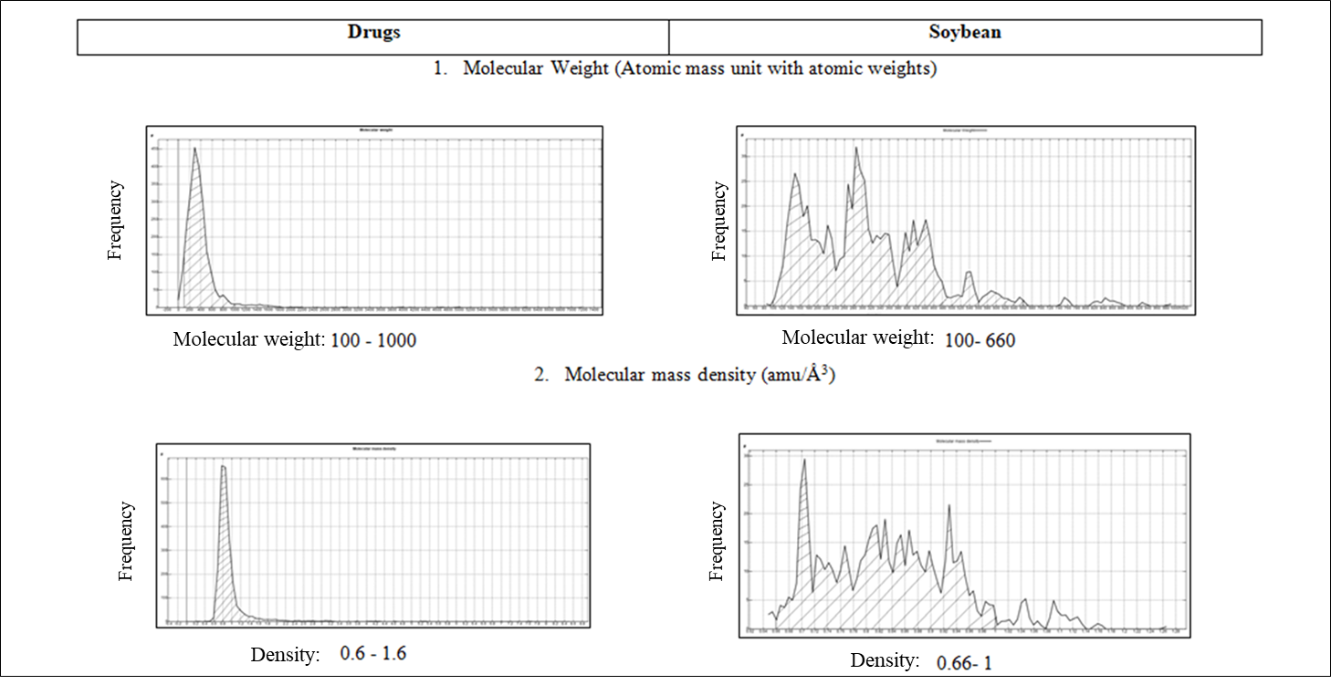

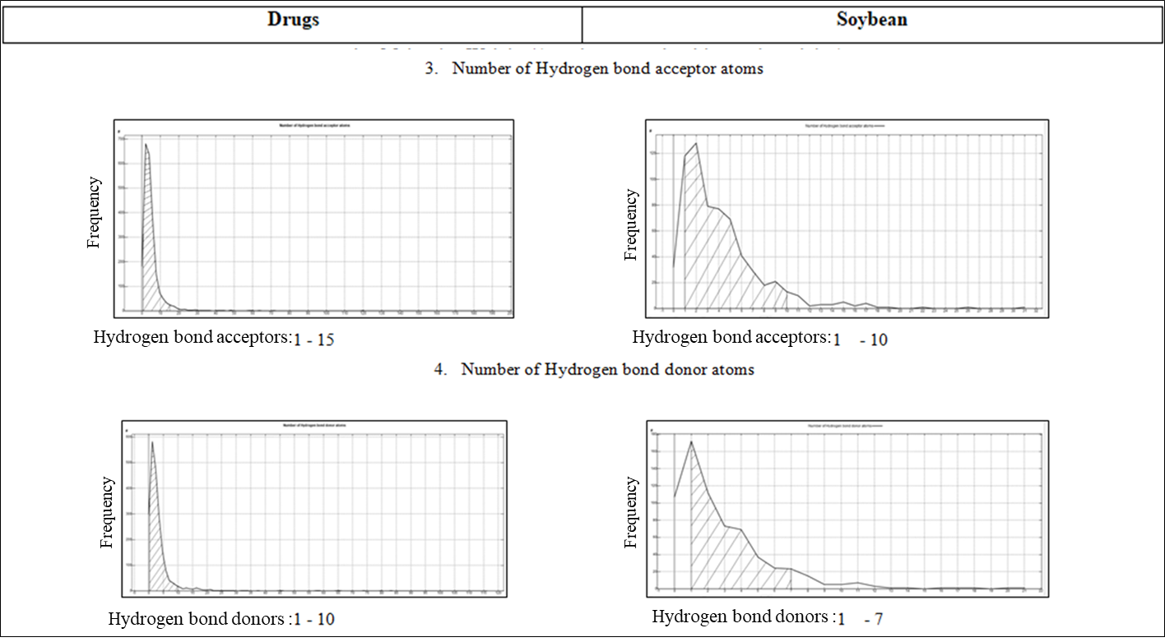

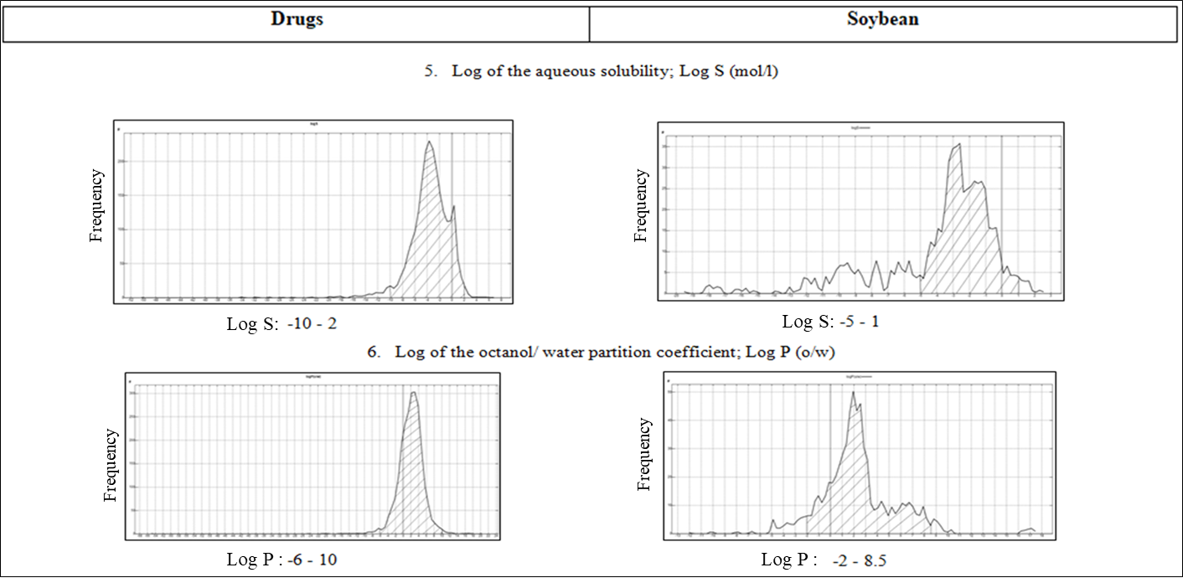

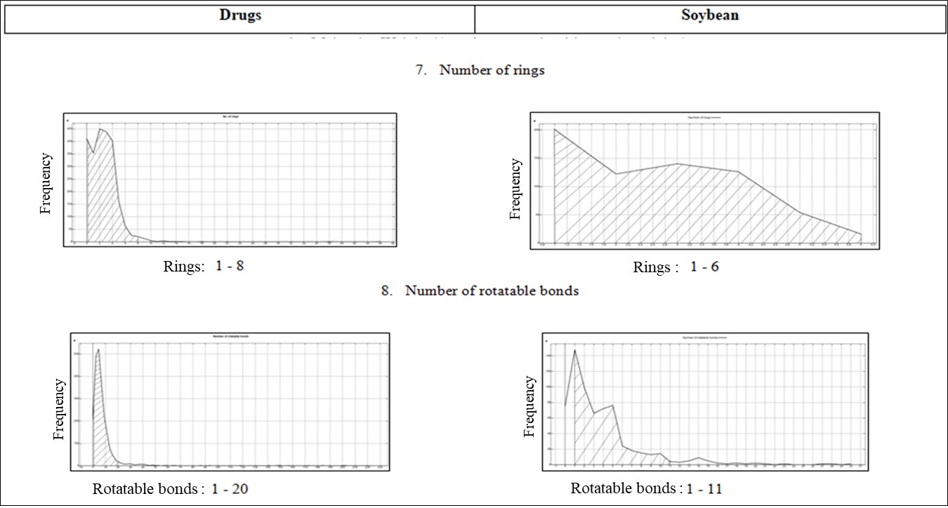

**Supplementary** **Fig. 1**: Histograms depicting descriptor ranges of soybean small molecules and approved drugs

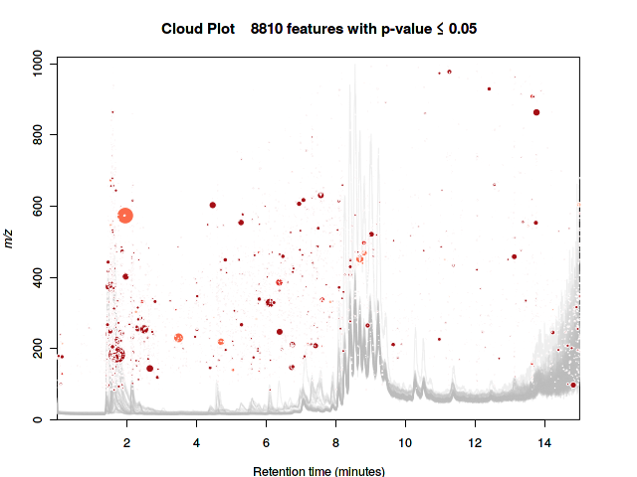

**Supplementary** **Fig. 2**: Cloud plot generated by XCMS for positive ion mode

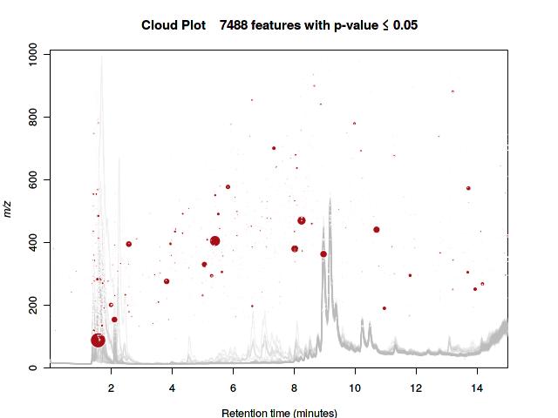

**Supplementary** **Fig. 3**: Cloud plot generated by XCMS for negative ion mode

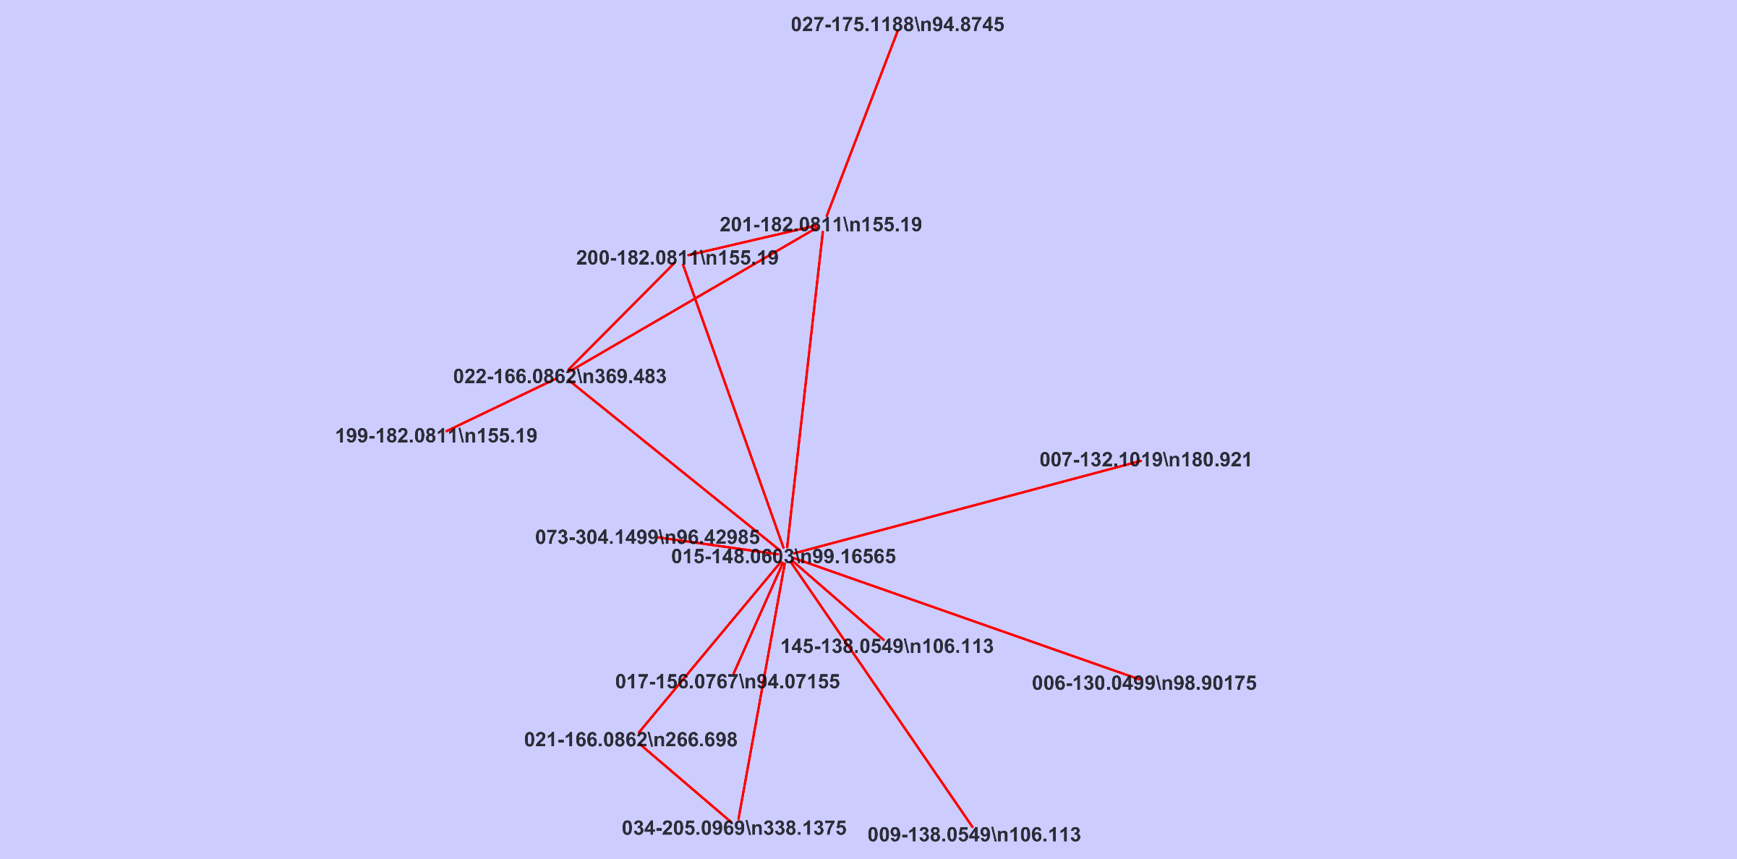 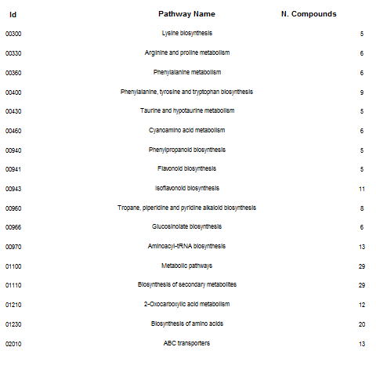

1. **Variety 1 - NRC119**

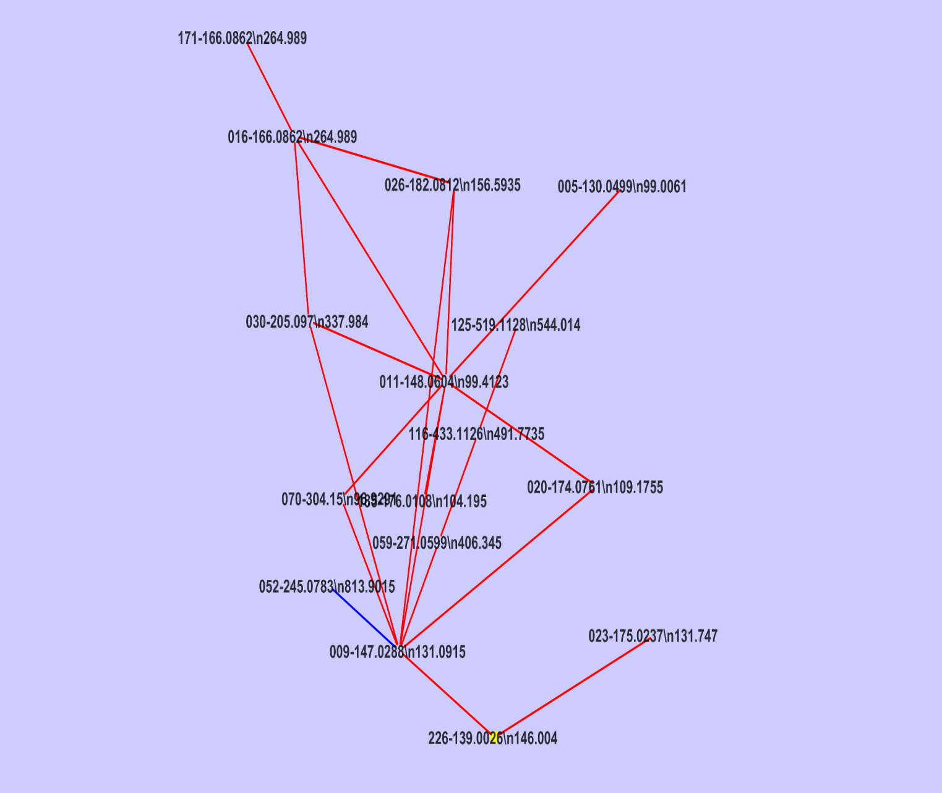 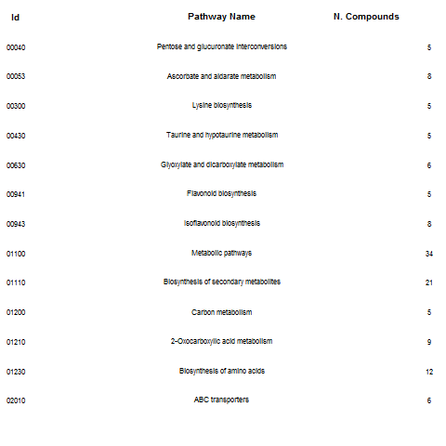

1. **Variety 2 - JS335**

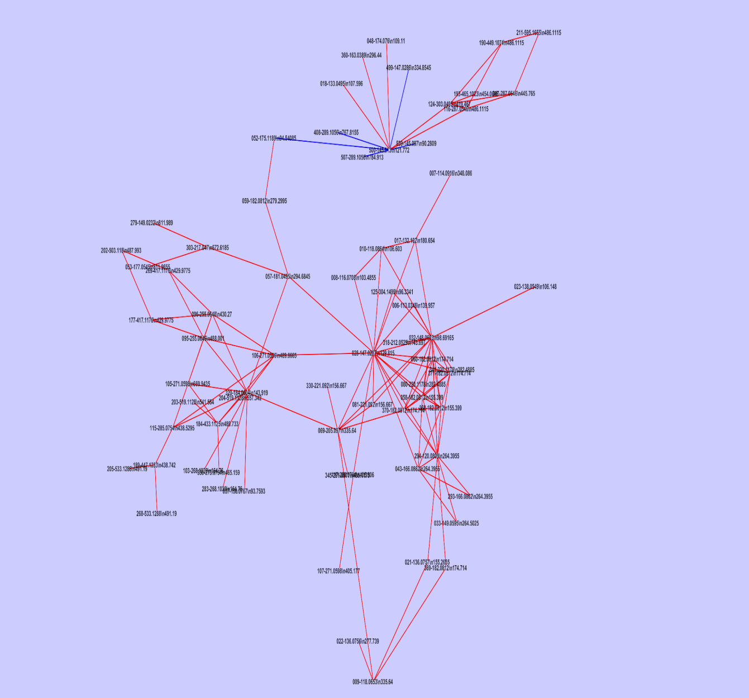 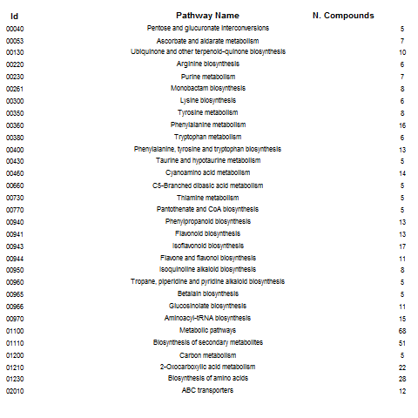

1. **Variety 3 - JS7105**

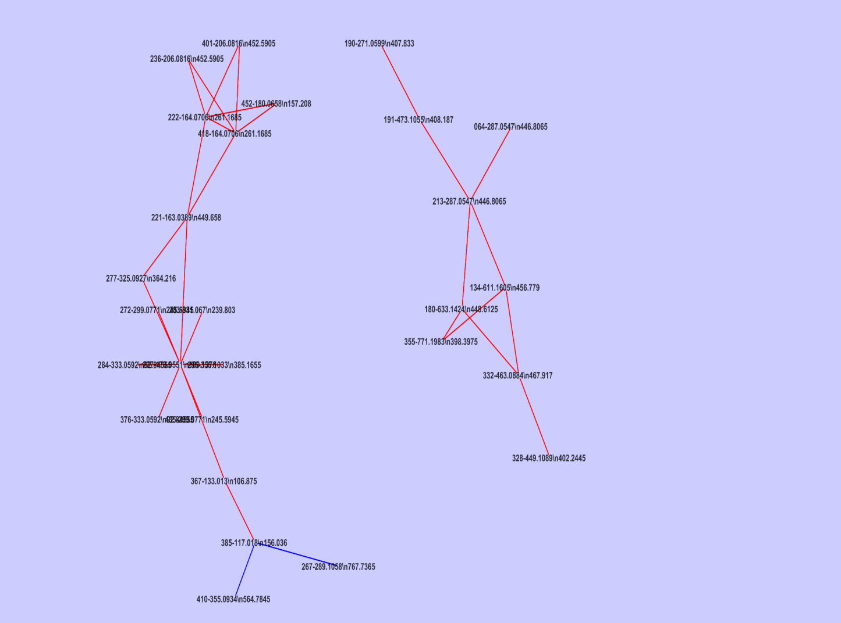 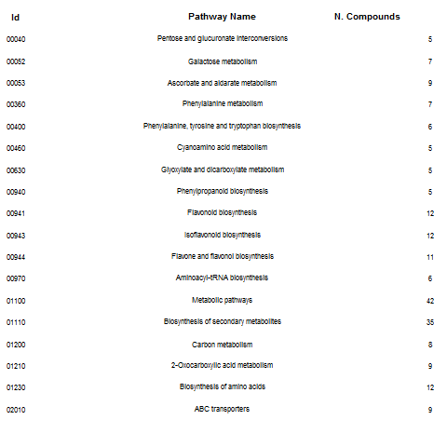

1. **Variety 4 - JS9305**

**Supplementary** **Fig. 4**: Metabolic pathway network with the list of pathway names and the number of molecules involved for four varieties of soybean (Retrieved from KEGG soybean pathways).

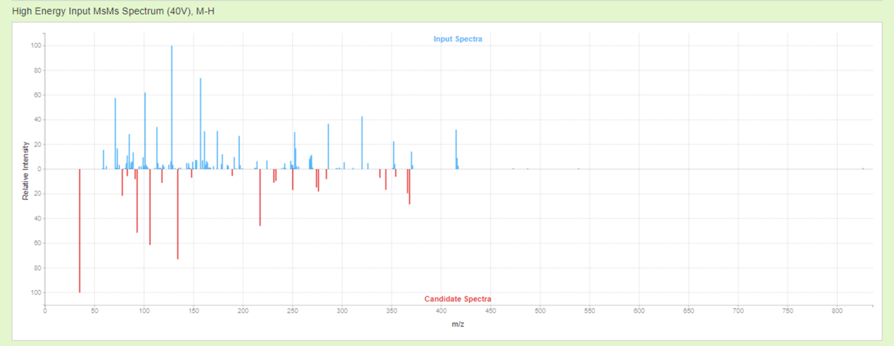

1. 1-Acetoxypinoresinol

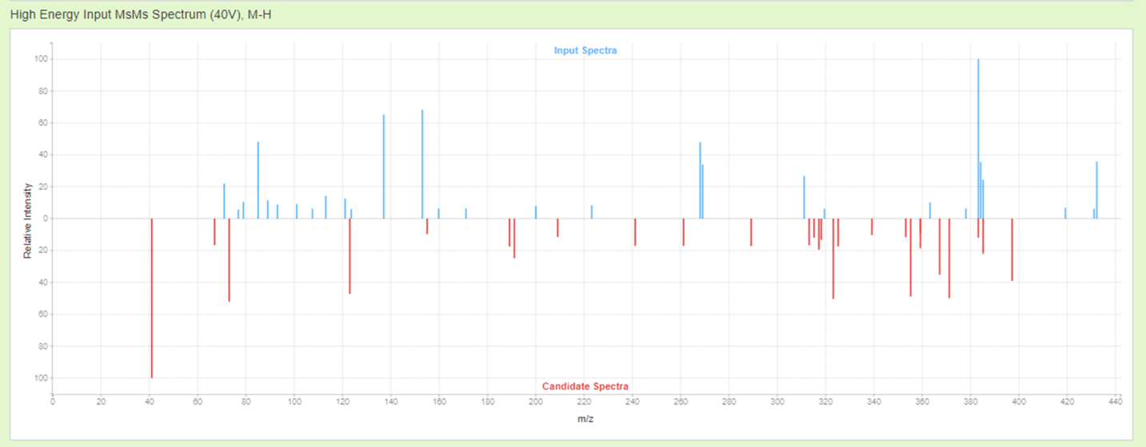

1. Cinegalline

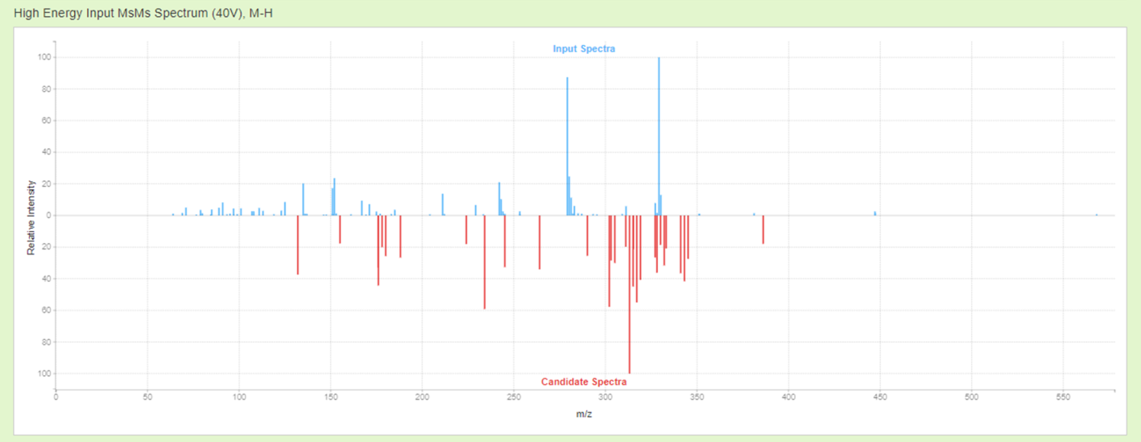

1. Lonchocarpenin

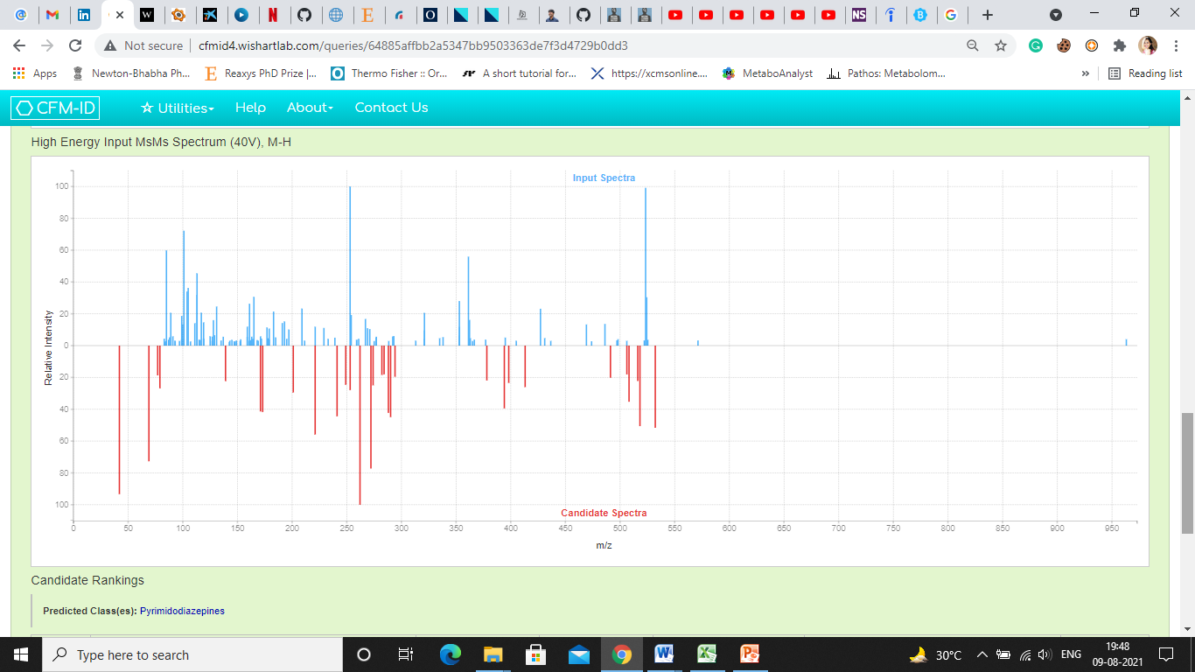

1. Decuroside III

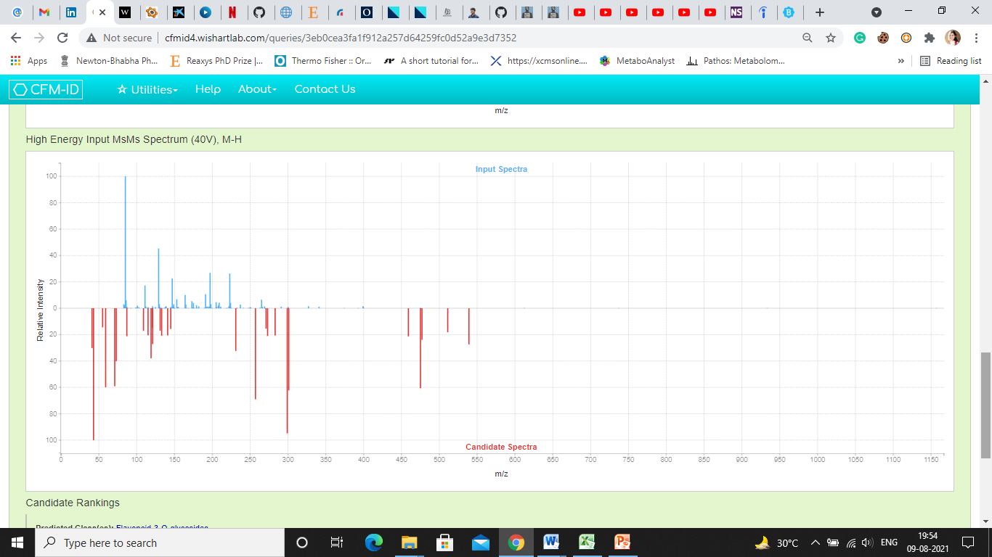

1. Quercetin 3-O-[beta-D-xylosyl-(1->2)-beta-D-glucoside]

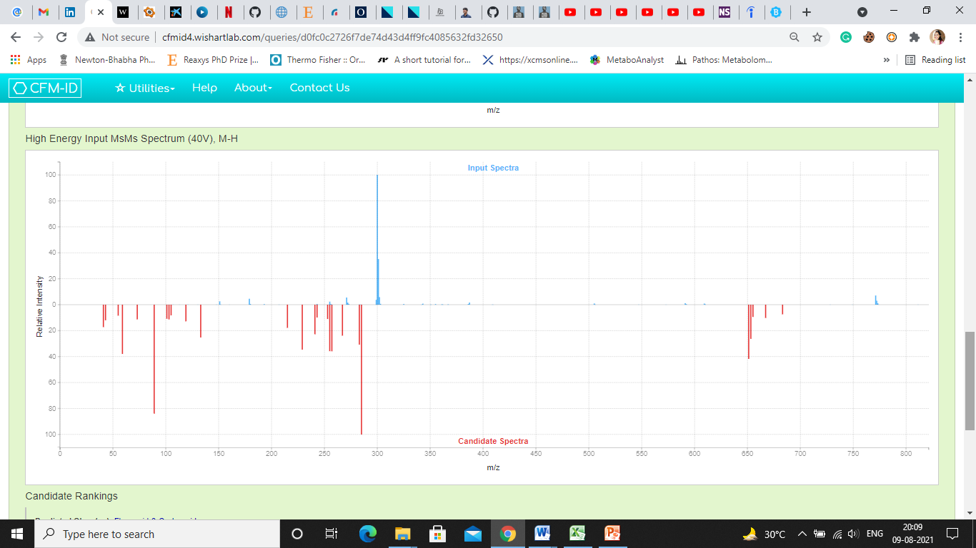

1. Kaempferol 3-sophorotrioside

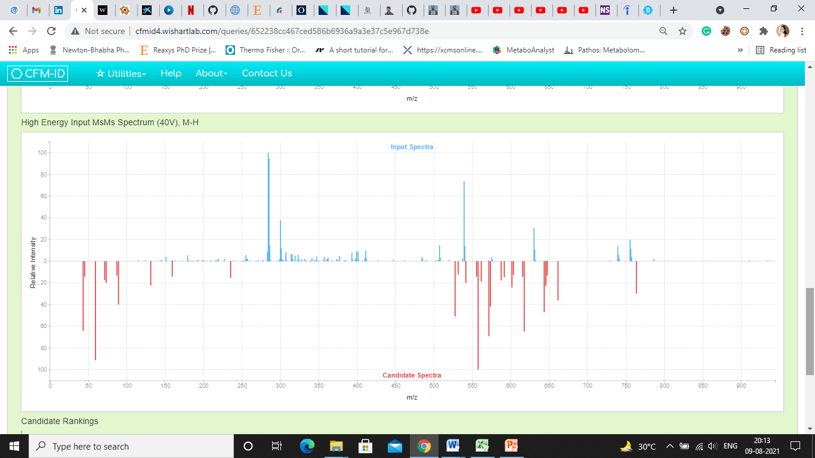

1. Yiamoloside B

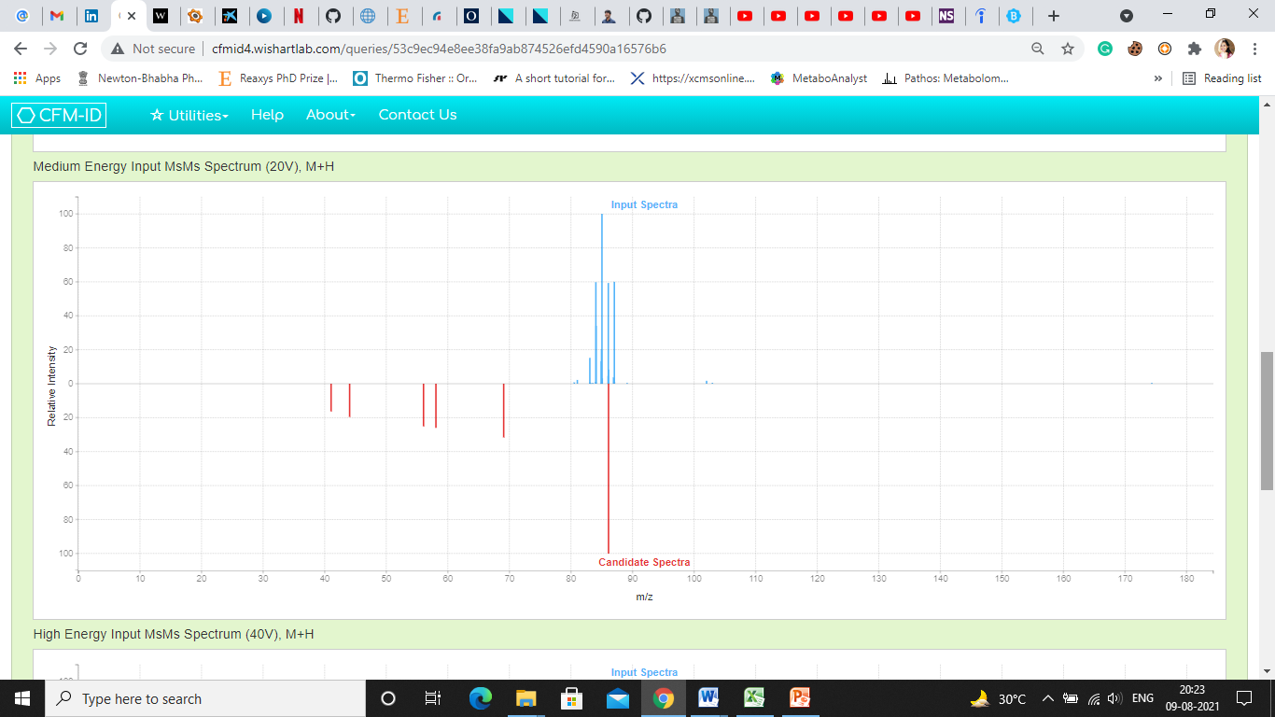

1. Piperidine

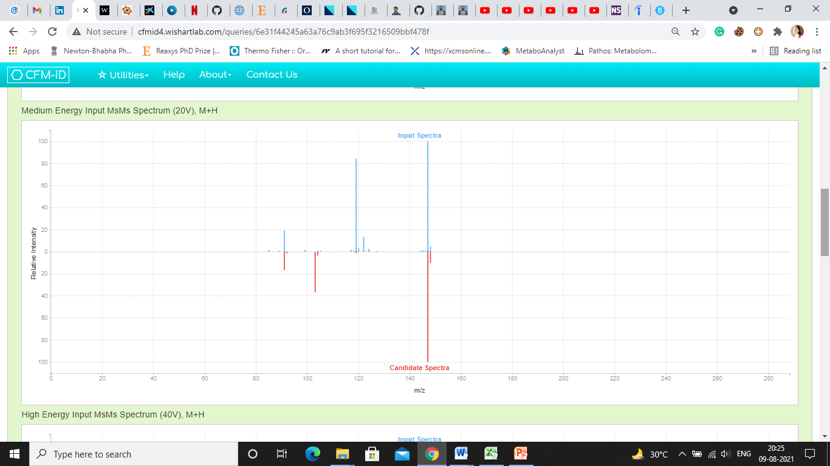

1. Coumarin

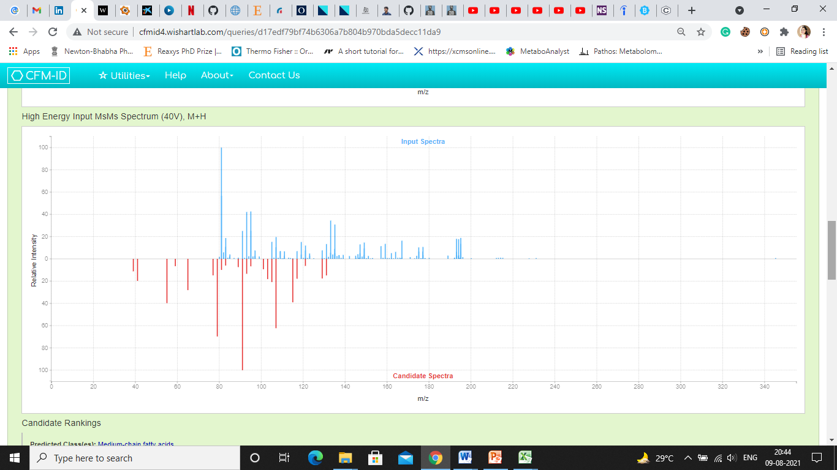

1. Zingerone

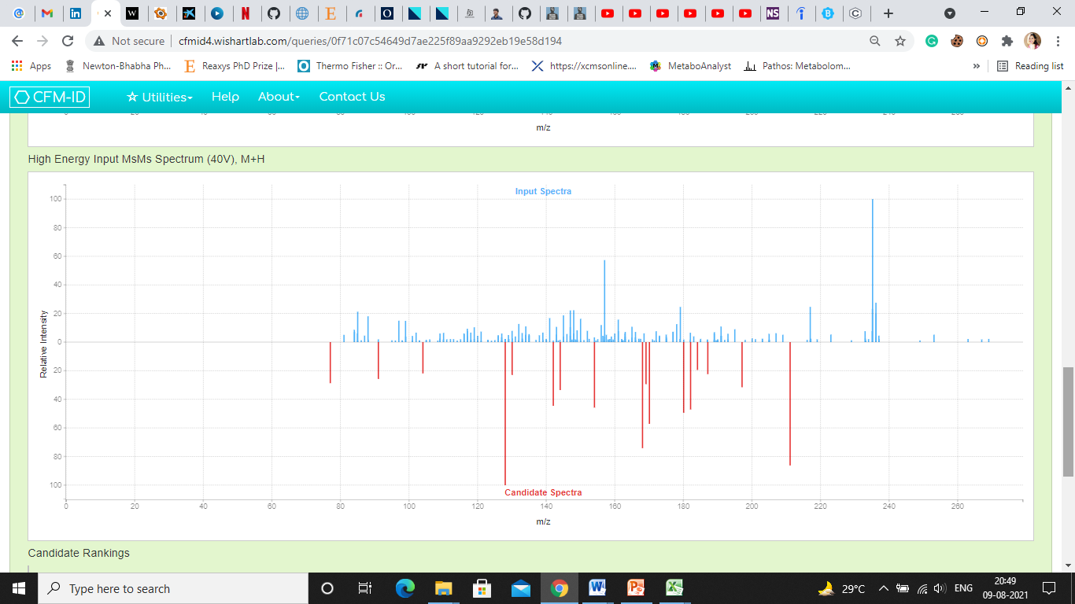

1. Lophophorine

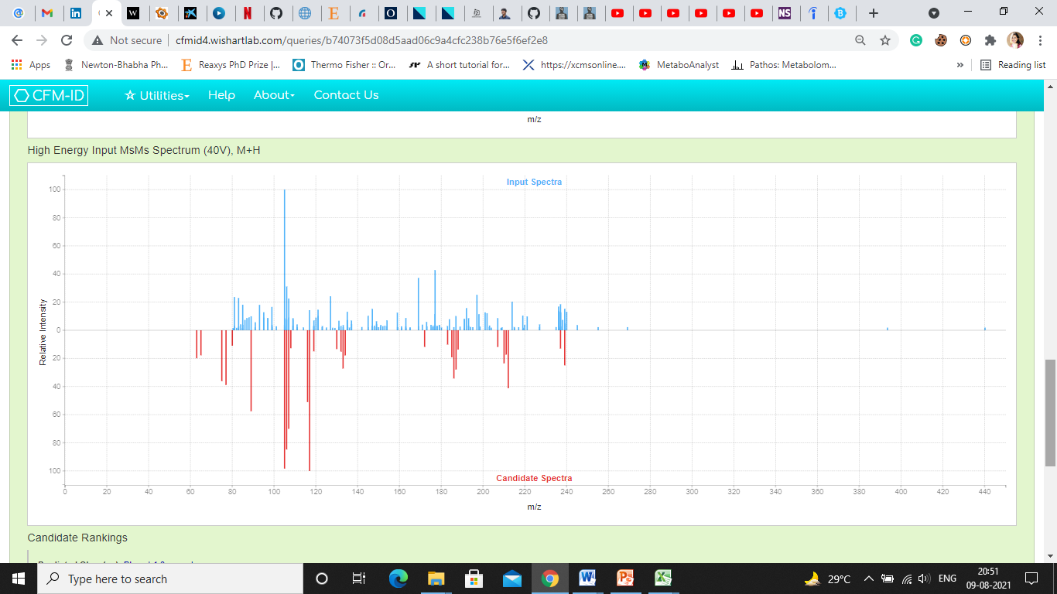

1. Halfordinol

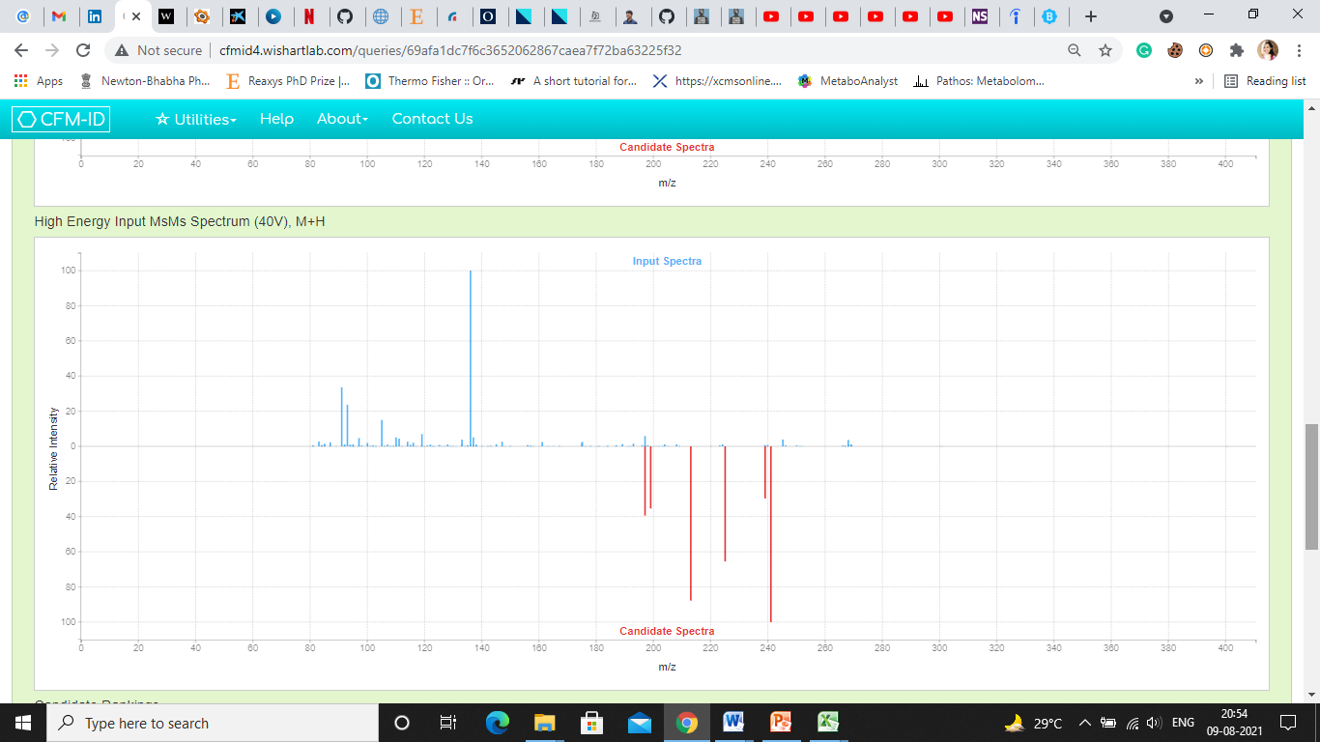

1. Coumestrol

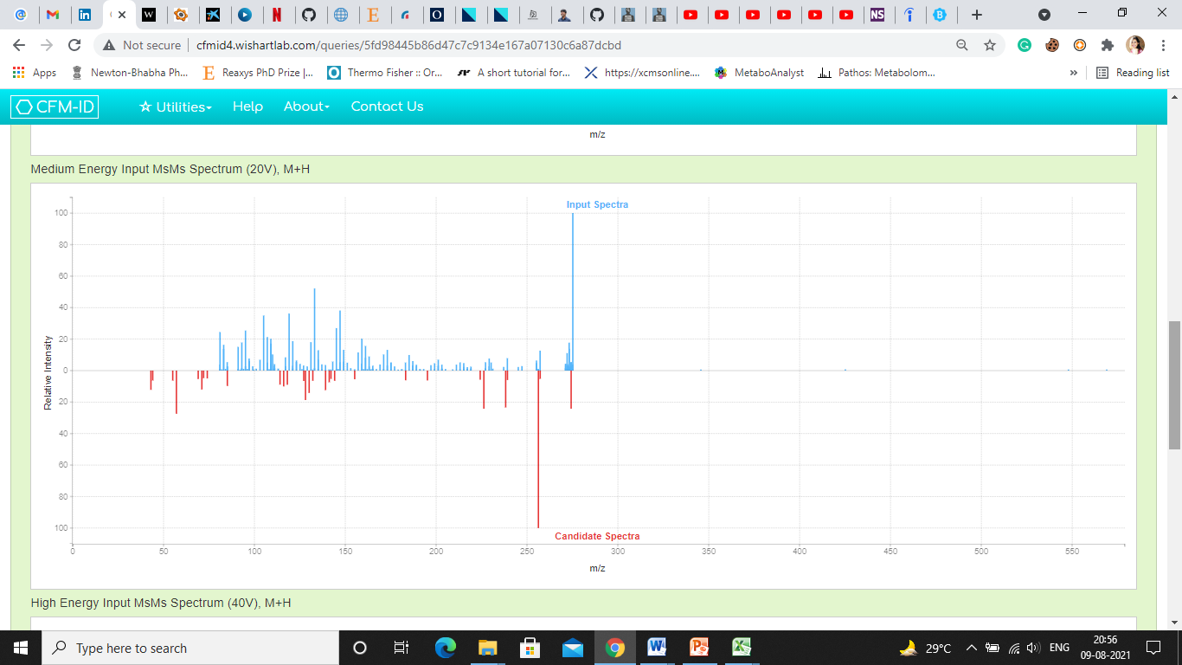

1. Hexadecasphinganine

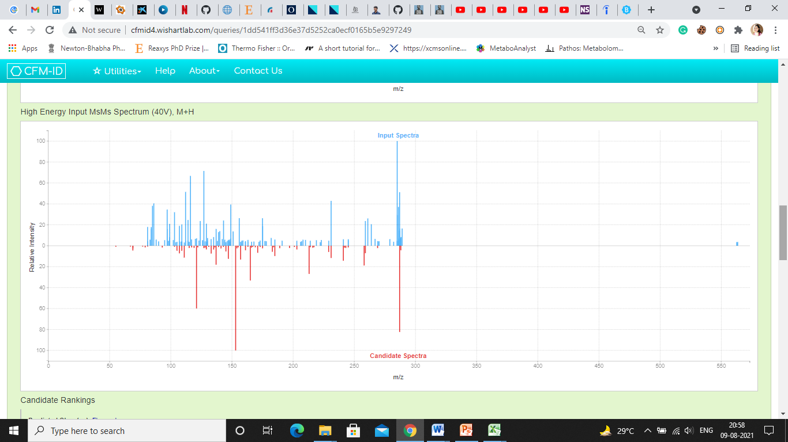

1. Aurantinidin

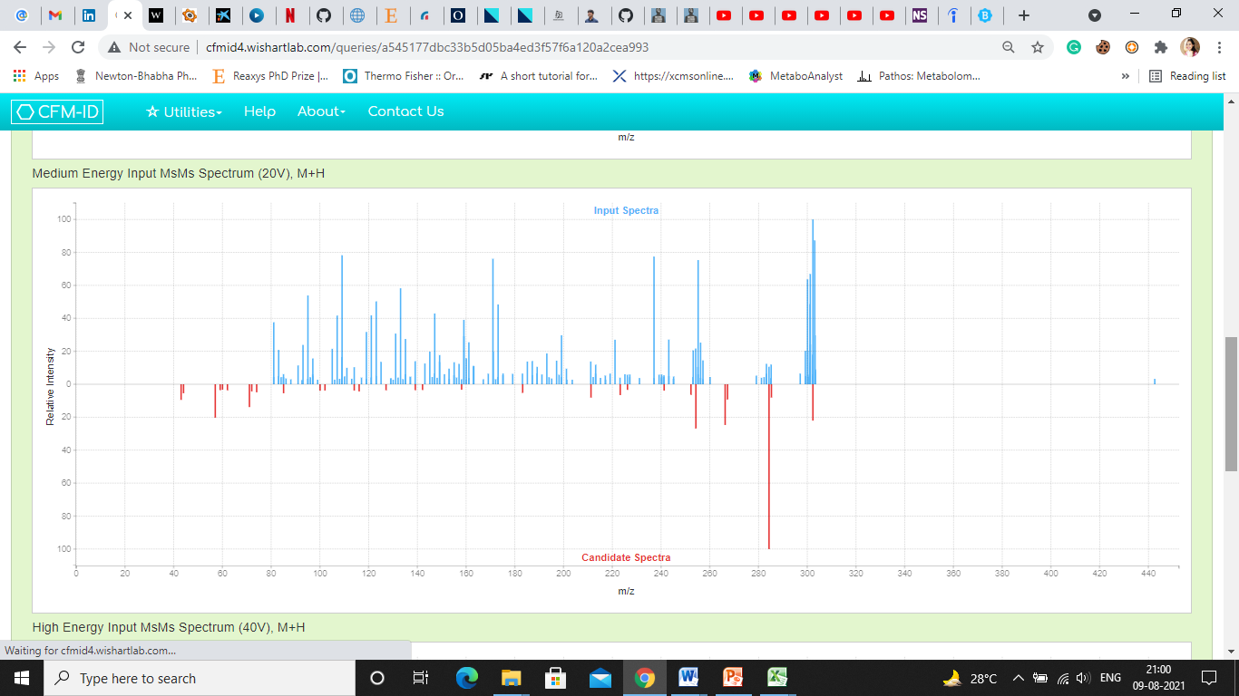

1. Sphinganine

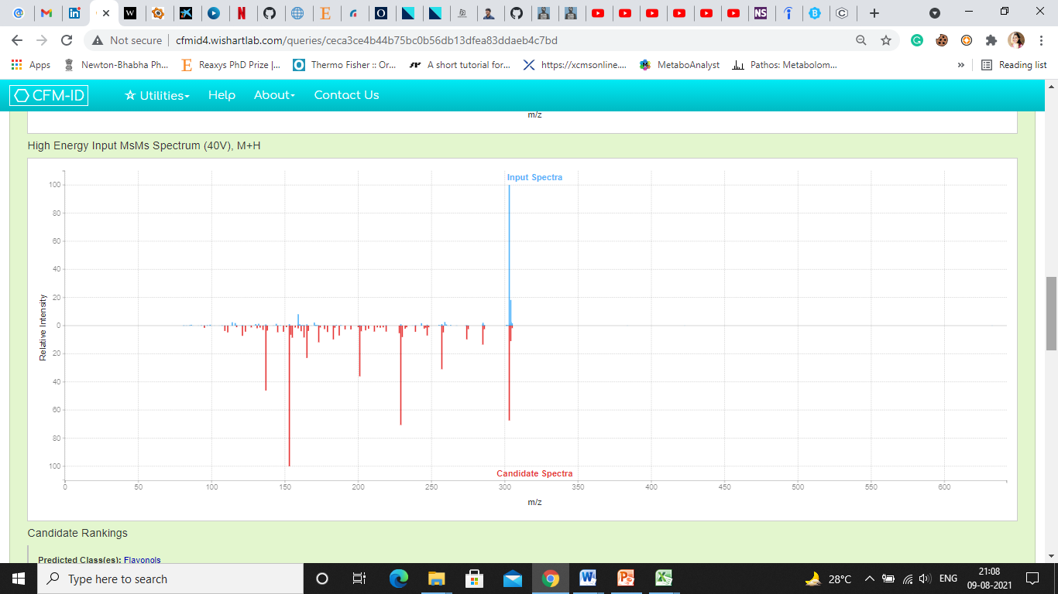

1. Quercetin

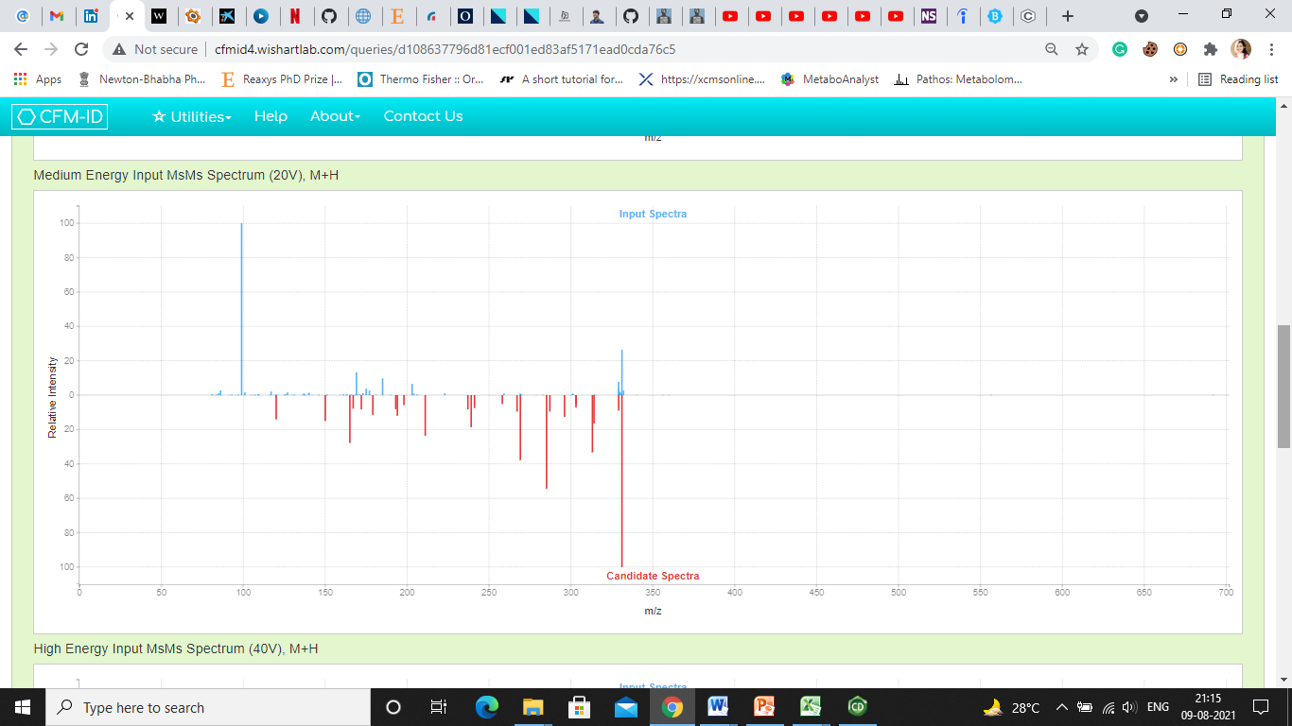

1. Miraxanthin-III

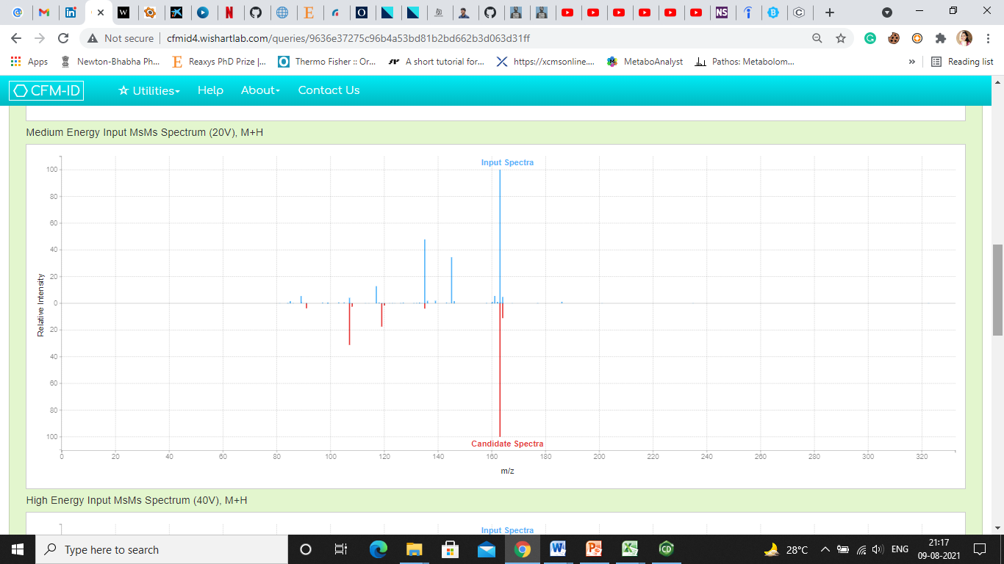

1. Umbelliferone

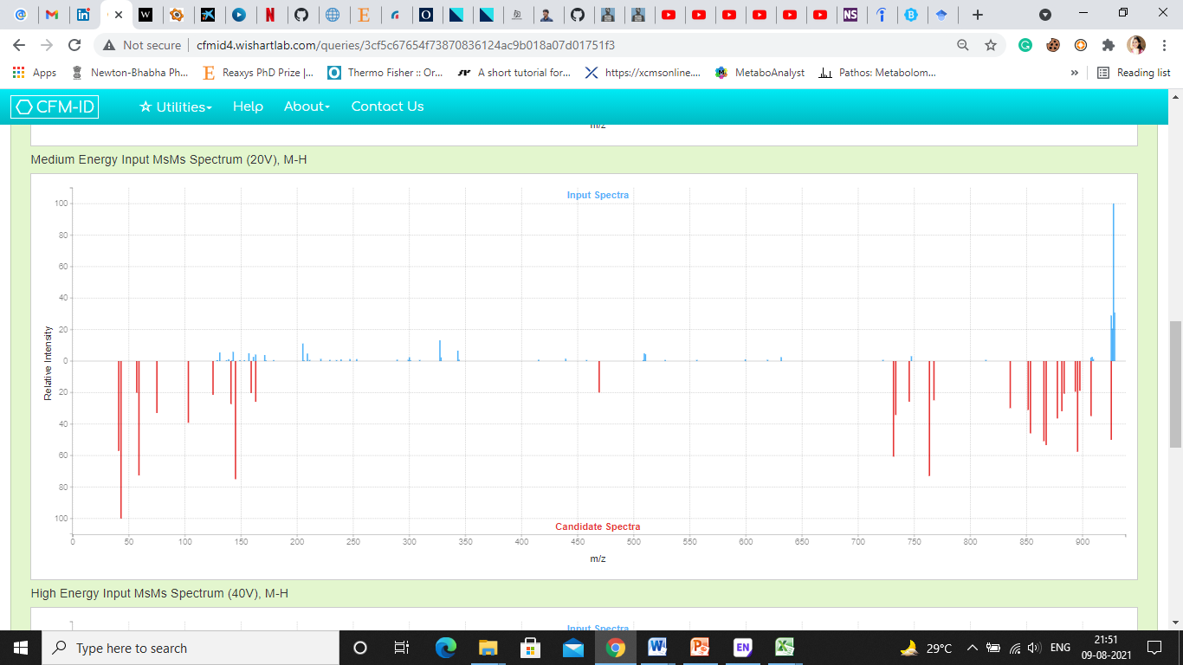

1. Saikosaponin BK1

**Supplementary** **Fig. 5**: MS/MS spectral similarities of 20 molecules compared to the *in-silico* spectra from CFM-ID webserver